types of databases available in the market:

* [Centralised database](https://www.tutorialspoint.com/Centralised-database).
* [Distributed database](https://www.tutorialspoint.com/Distributed-database).
* [Personal database](https://www.tutorialspoint.com/Personal-database).
* [End-user database](https://www.tutorialspoint.com/End-User-Database).
* [Commercial database](https://www.tutorialspoint.com/Commercial-Database).
* [NoSQL database](https://www.tutorialspoint.com/NoSQL-Databases).
* [Operational database](https://www.tutorialspoint.com/Operational-Database).
* [Relational database](https://www.tutorialspoint.com/Relational-Databases).
* [Cloud database](https://www.tutorialspoint.com/Cloud-Databases).
* [Object-oriented database](https://www.tutorialspoint.com/Object-Oriented-Databases).
* [Graph database](https://www.tutorialspoint.com/Graph-Databases).

**1. Centralised Database**

* The information(data) is stored at a centralized location and the users from different locations can access this data.

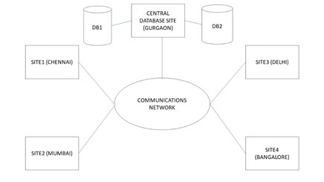

#### 2.Distributed Database

Just opposite of the centralized database concept, the data is not at one place and is distributed at various sites of an organization. The distributed database has contributions from the common database as well as the information captured by local computers also.

**The data is not at one place and is distributed at various sites of an organization.**